### **automate the creation of a ticket with Notification Manager**

### **Using this approach allows the tasks to be added to the rule instead of defining a failure event on every task.**

**Create a schedule setting :**

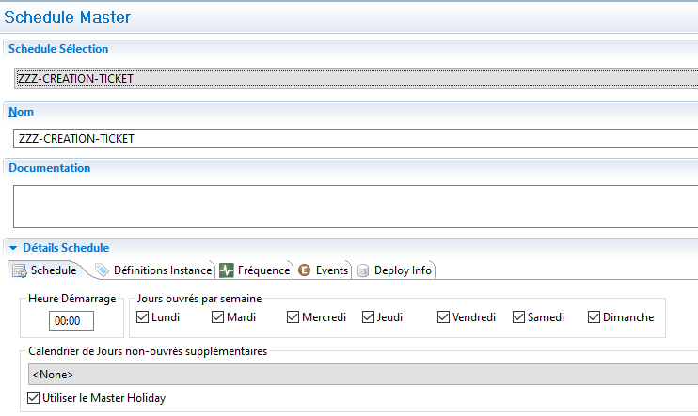

**Create a job null in the schedule setting**

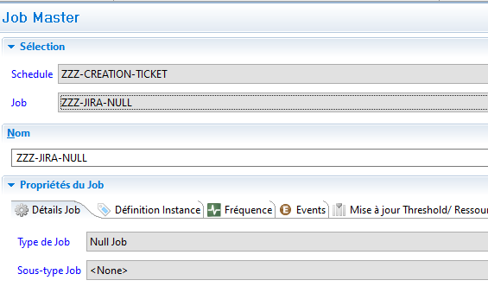

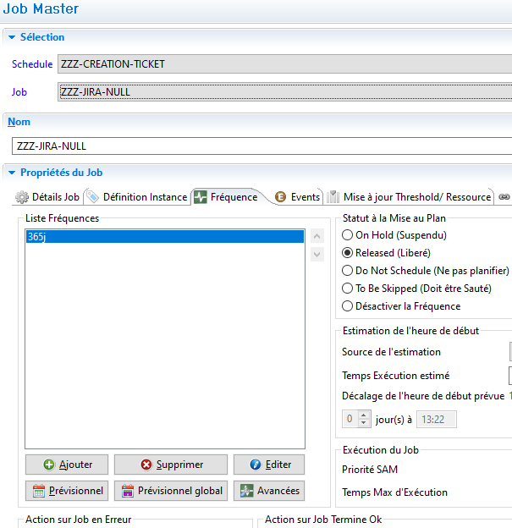

**Create a Windows job in the schedule setting**

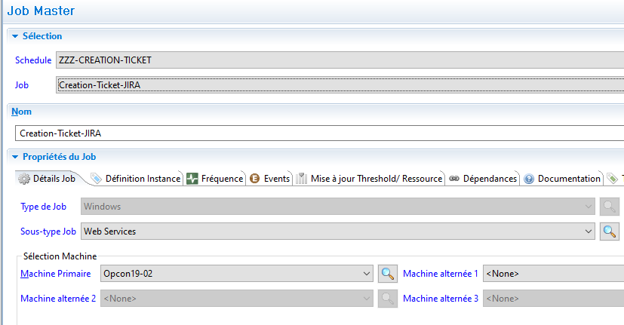

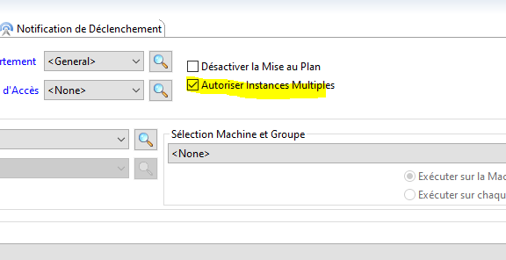

**Import your Template**



**Define Instance (**Add all the information you need to fill in your ticket)

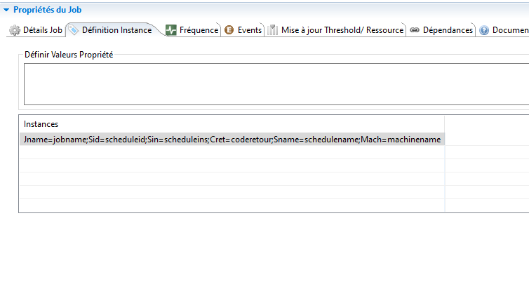

**Add an All days frequency to the job (**

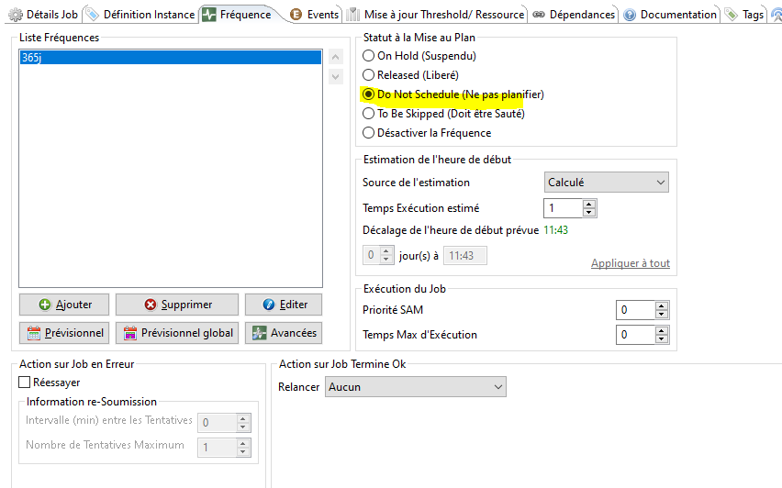

**if necessary modify the body of step 1 with your elements**

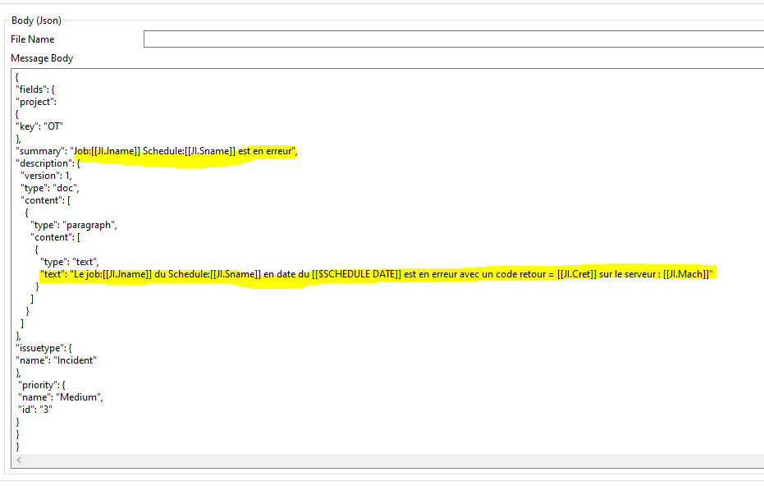

Using Notification Manager, select the *Jobs* tab and create a new Group called *JIRA*.

Once the Group has been created, select the *JIRA* Group, perform a ‘*right-click*’ and select *Add Job Trigger*. In the *Add Job Trigger* selection, select *Job Failed*.

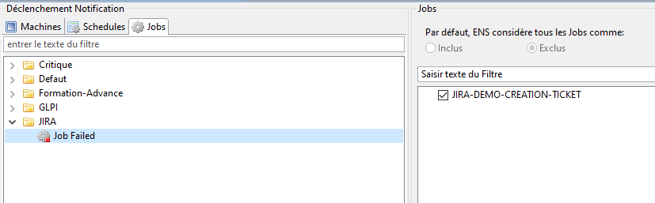

In the Notification Definitions section, select *Send OpCon/xps Events*. In the Event tab, select Add and then select $JOB:ADD event and enter the following:

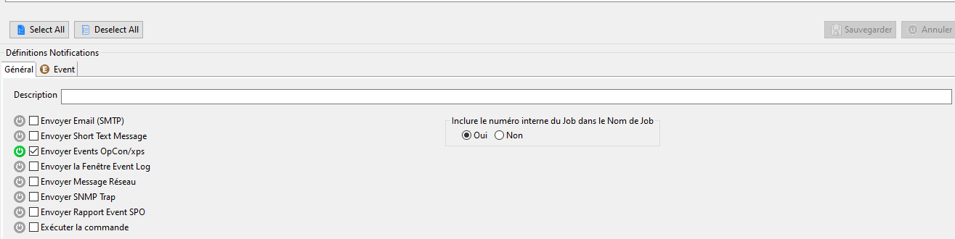

[[$SCHEDULE DATE]],ZZZ-CREATION-TICKET,Creation-Ticket-JIRA,365j,Jname=[[$JOB NAME]];Sid=[[$SCHEDULE ID]];Sin=[[$SCHEDULE INST]];Cret=[[$JOB TERMINATION]];Sname=[[$SCHEDULE NAME]];Mach=[[$MACHINE NAME]],Y,

Where

* ZZZ-CREATION-TICKET schedule name
* Creation-Ticket-JIRA job name
* 365J the name of the frequency (must be an all days definition)
* Job instance job instance values